**Lab scenario**

Your organization is piloting a new infrastructure project. The CTO wants to know which Azure resources are being used on the new project. Your specific tasks are:

* Create a way to tag the project resources.
* Don't allow resources to be created without the resource tag.
* If a resource is created without the tag, automatically add the tag.

**Architecture diagram**

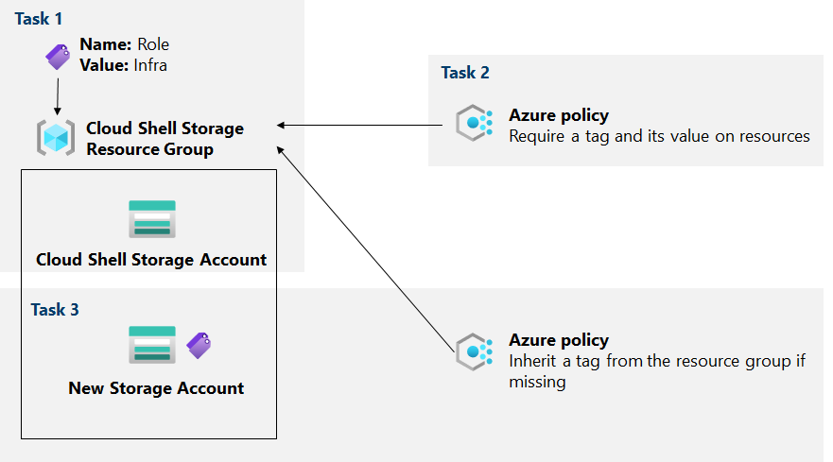

[**https://mslabs.cloudguides.com/guides/AZ-104%20Exam%20Guide%20-%20Microsoft%20Azure%20Administrator%20Exercise%203**](https://mslabs.cloudguides.com/guides/AZ-104%20Exam%20Guide%20-%20Microsoft%20Azure%20Administrator%20Exercise%203)

**Objectives**

* **Task 1**: *Create and assign tags* via the Azure portal.
  + For testing purposes, identify the Cloud Shell resource group.
  + Add a tag to the resource group. Assign the value of the tag.
  + Verify the storage account in the resource group doesn't have the tag.
* **Task 2**: *Enforce tagging by using an Azure policy*.
  + Locate the **Require a tag and its value on resources** built-in policy and review the definition.
  + Assign the policy to the resource group.
  + Configure the required tag: **Role** with a value of **Infra**.
  + Create a new storage account in the resource group and verify without the tag you can't create the resource.
* **Task 3**: *Automatically apply tagging by using an Azure policy.*
  + Assign the **Inherit a tag from the resource group if missing** built-in policy to the resource group.
  + Configure remediation to automatically add the **Role** tag if it is missing from a new resource.
  + Create a new storage account and verify the tag and value are added.

LAB: manage governance via Azure policy

Task 1

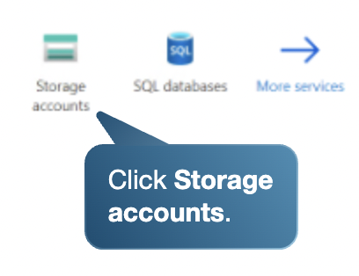

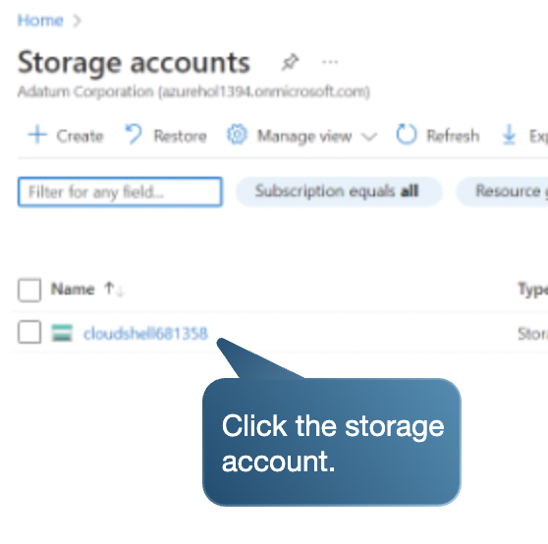

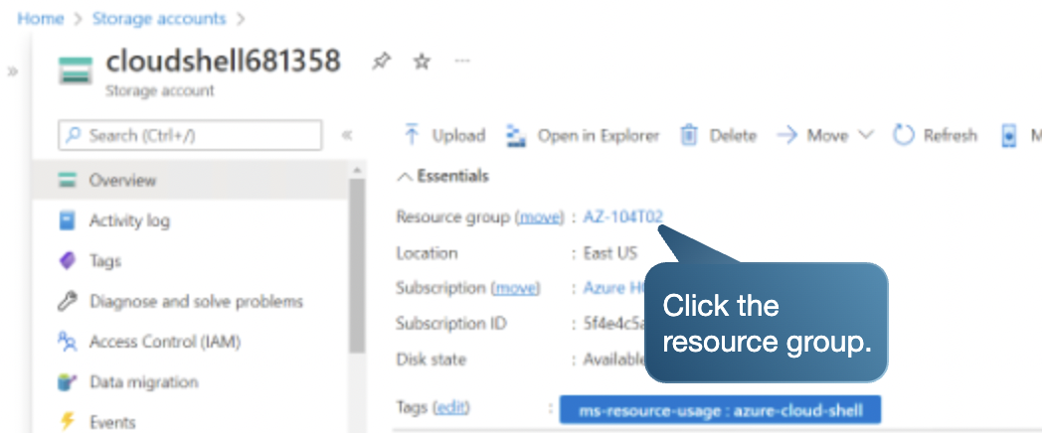

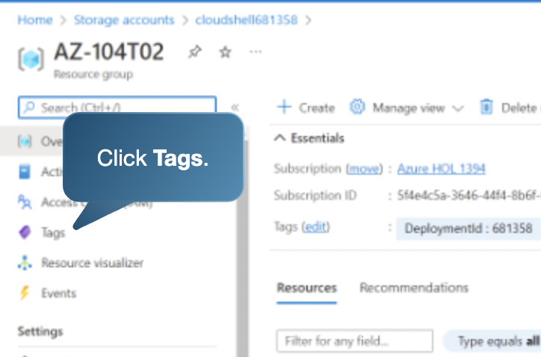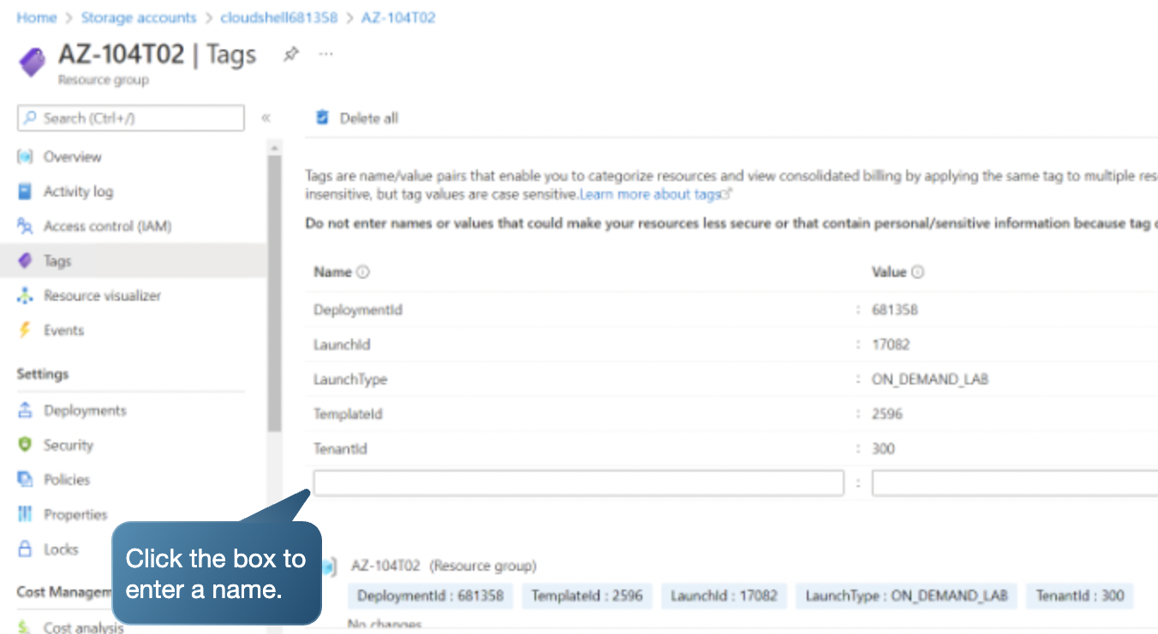  
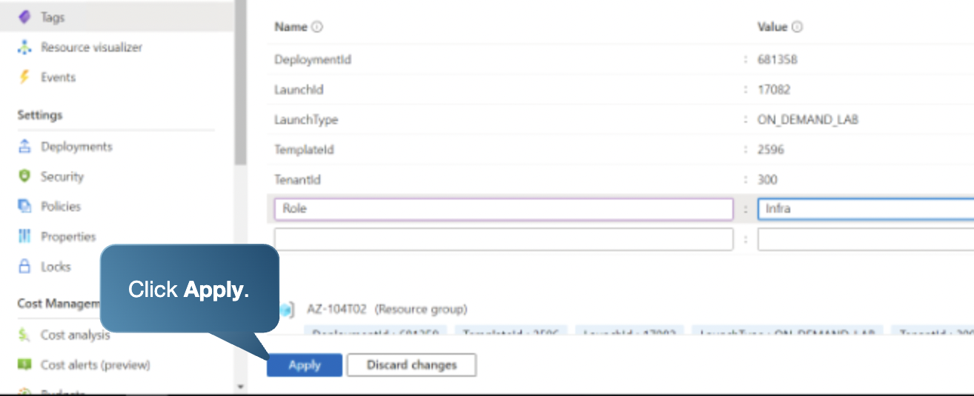

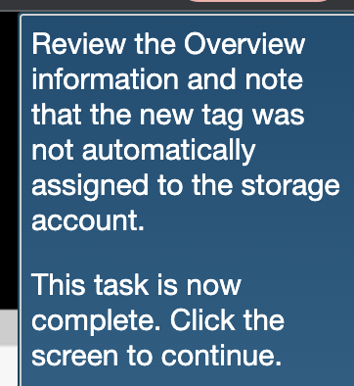

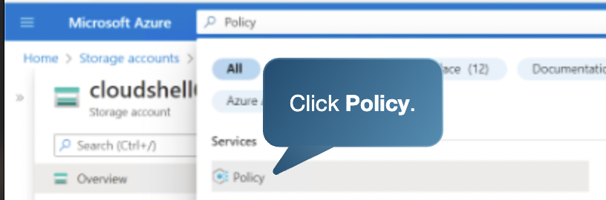

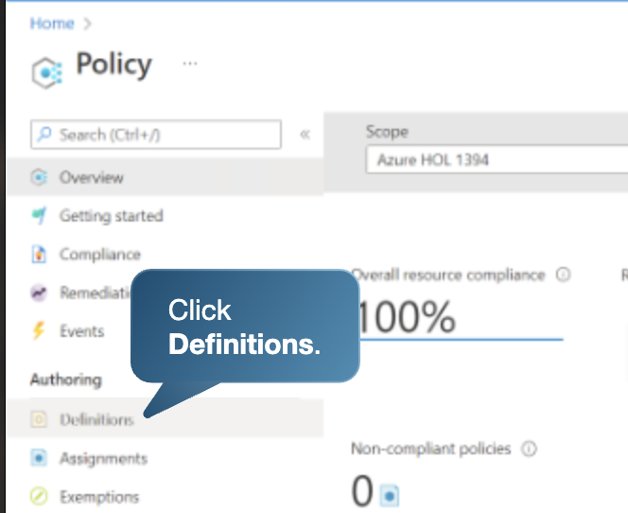

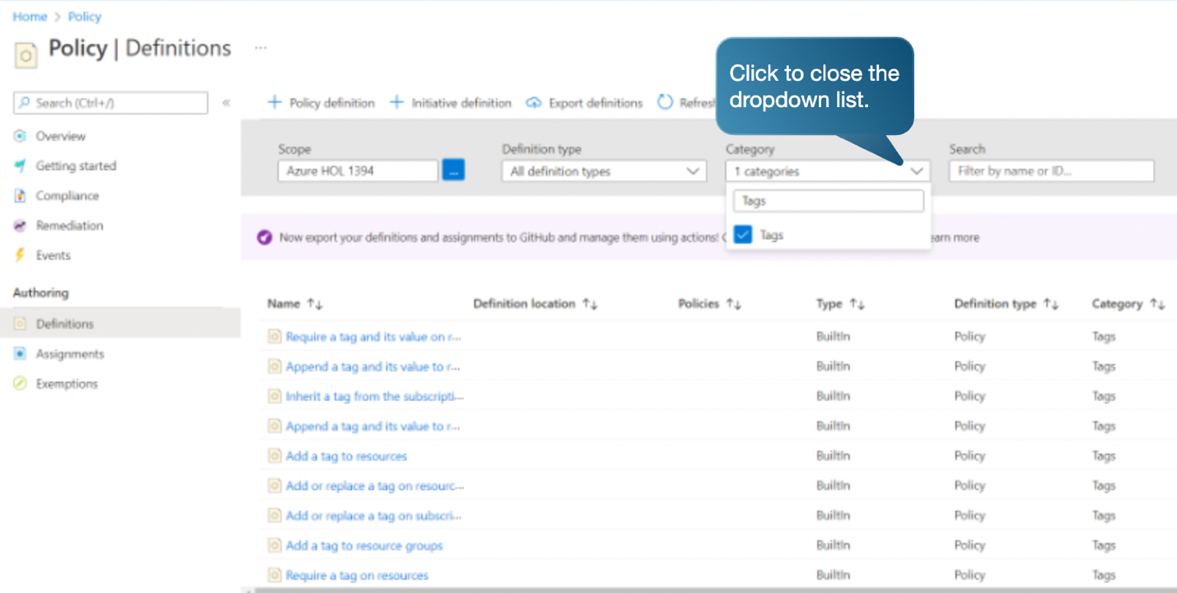



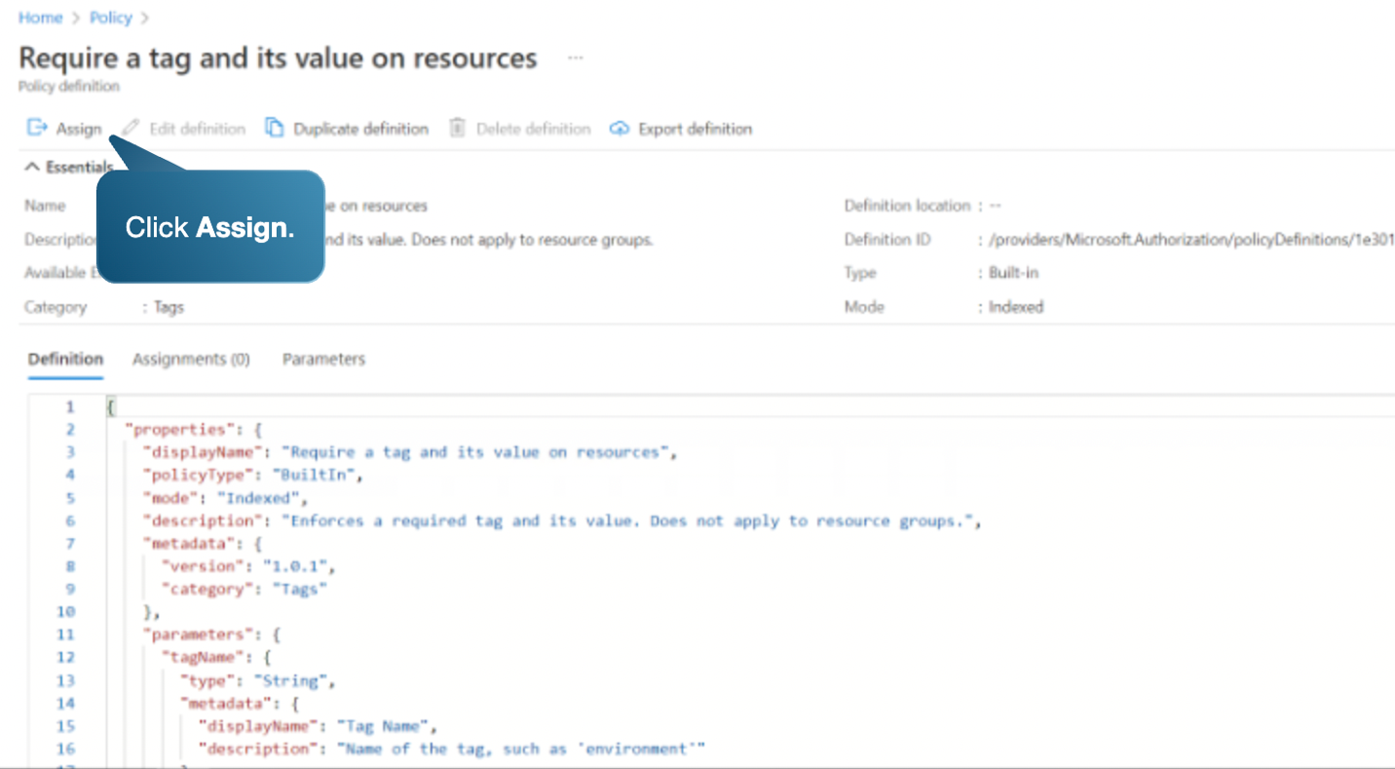

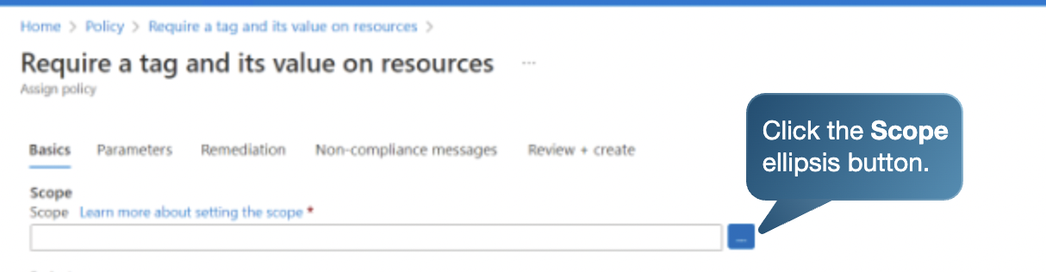

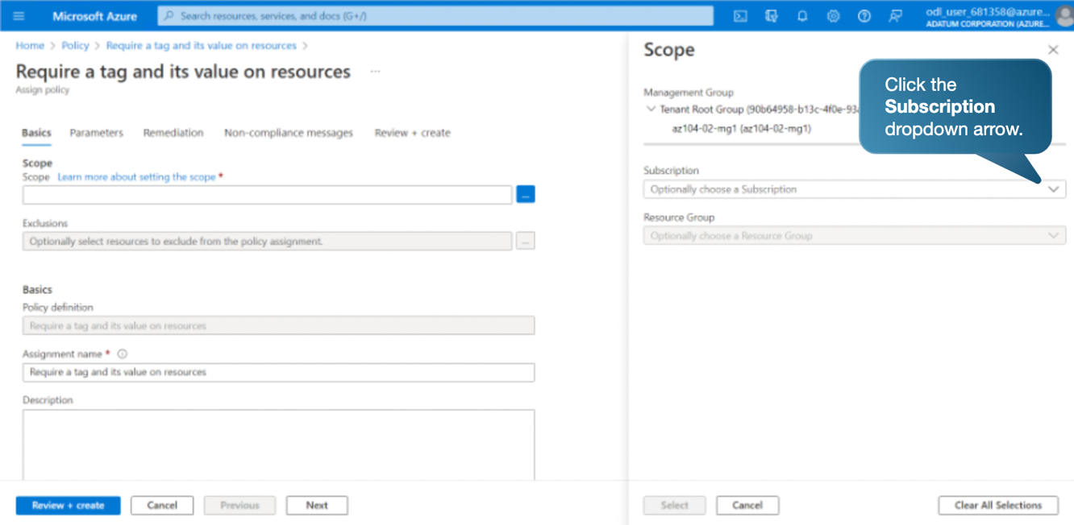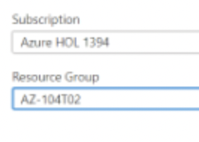



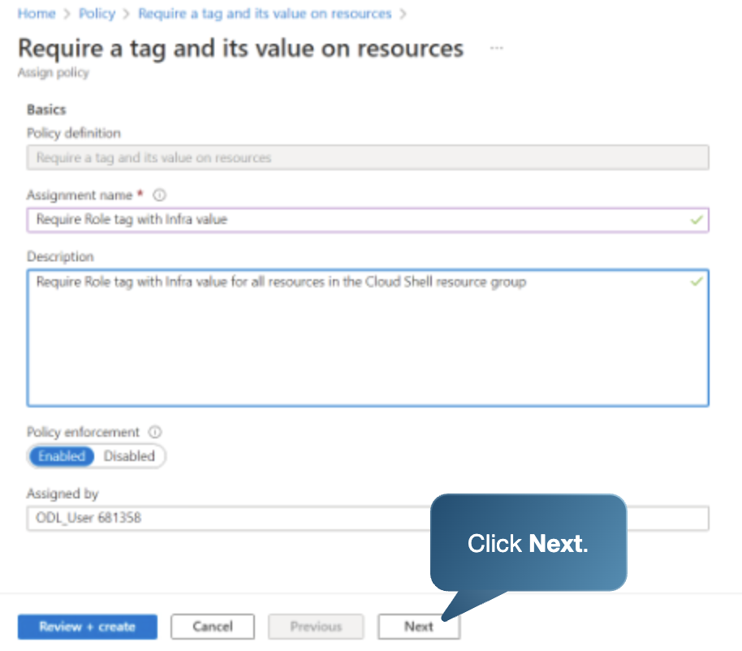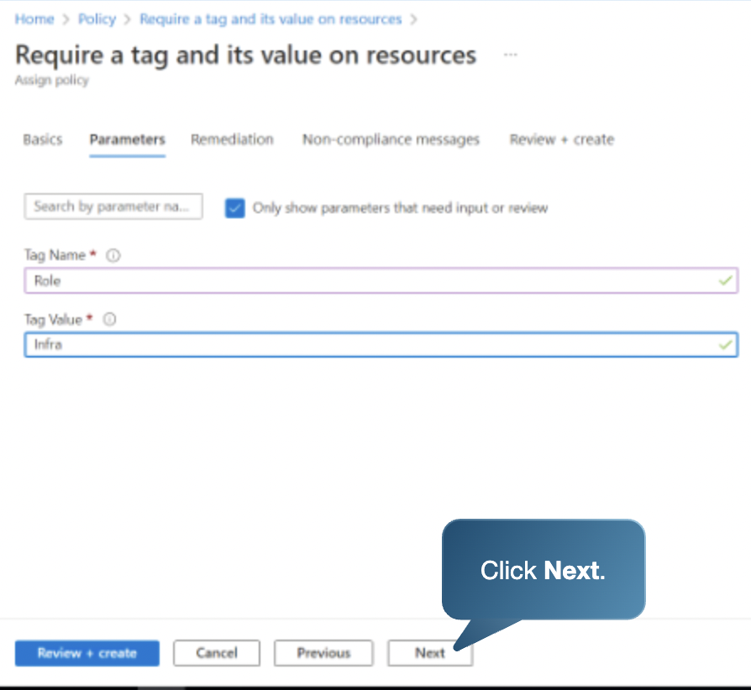

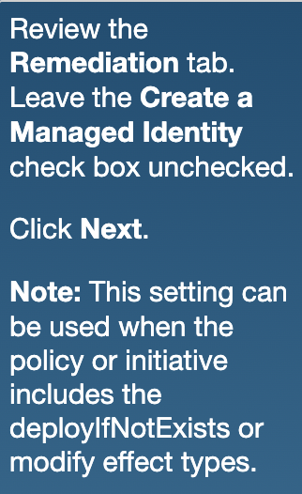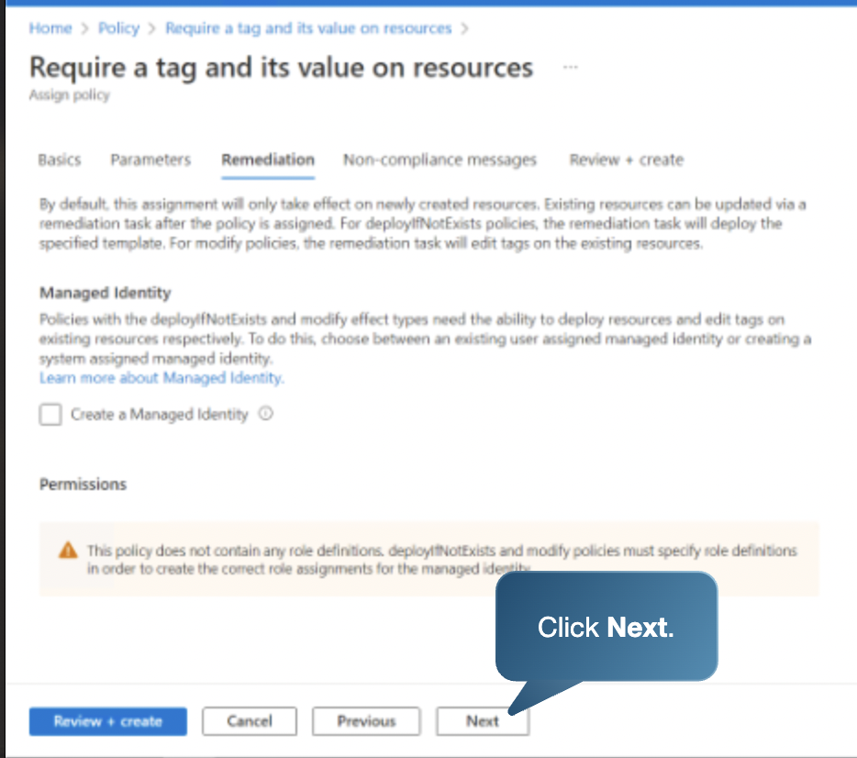 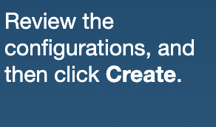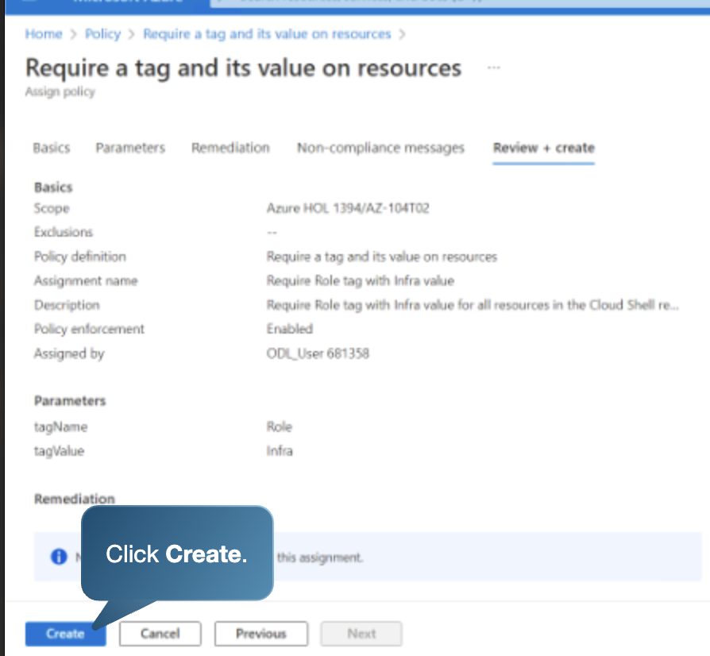

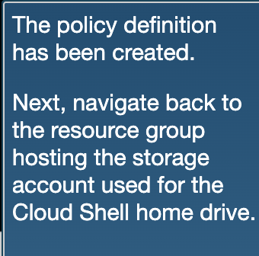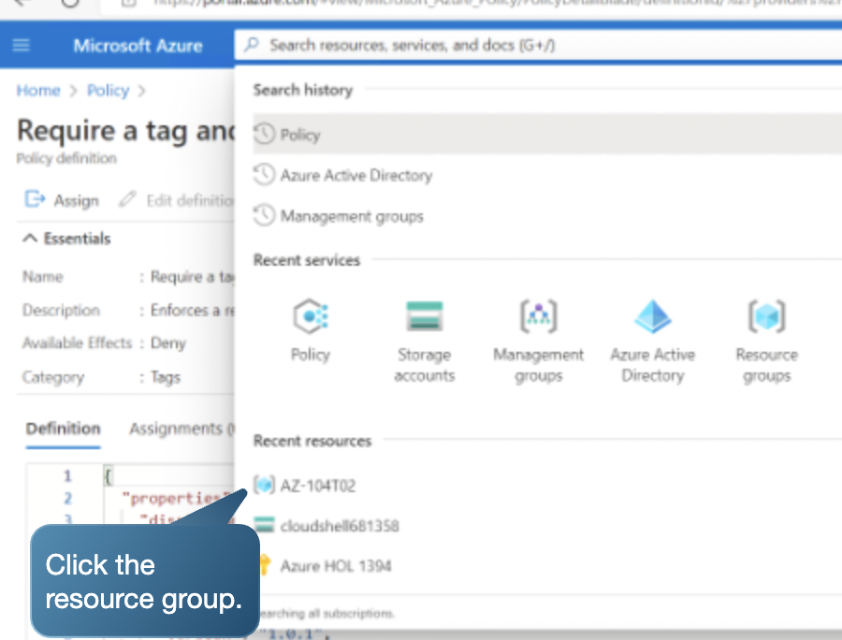

Create

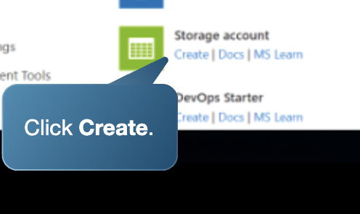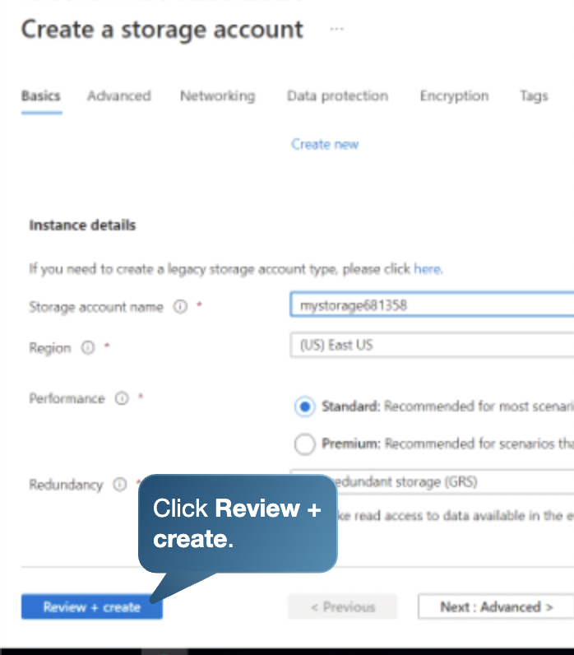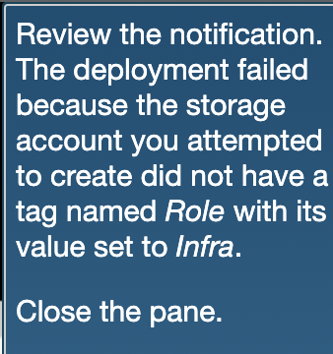

Resource oluşmadı.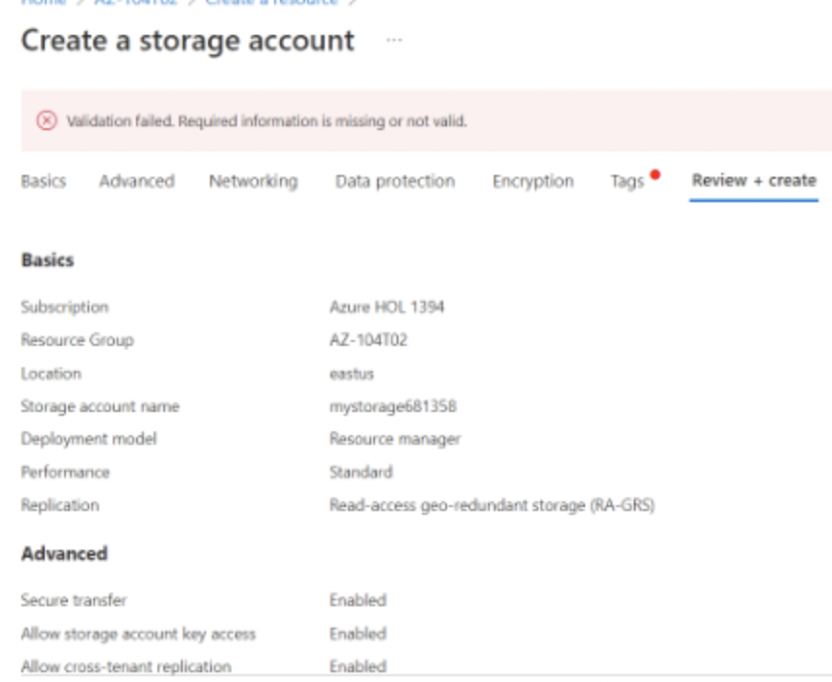



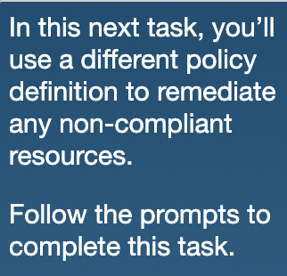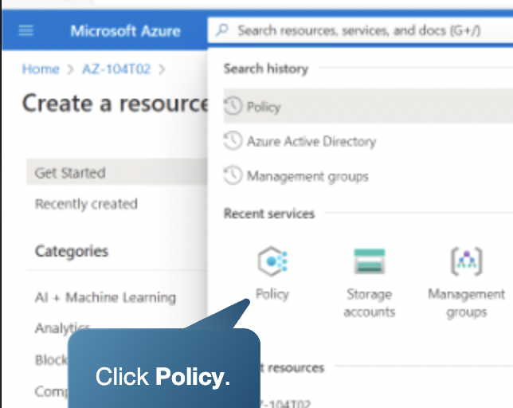

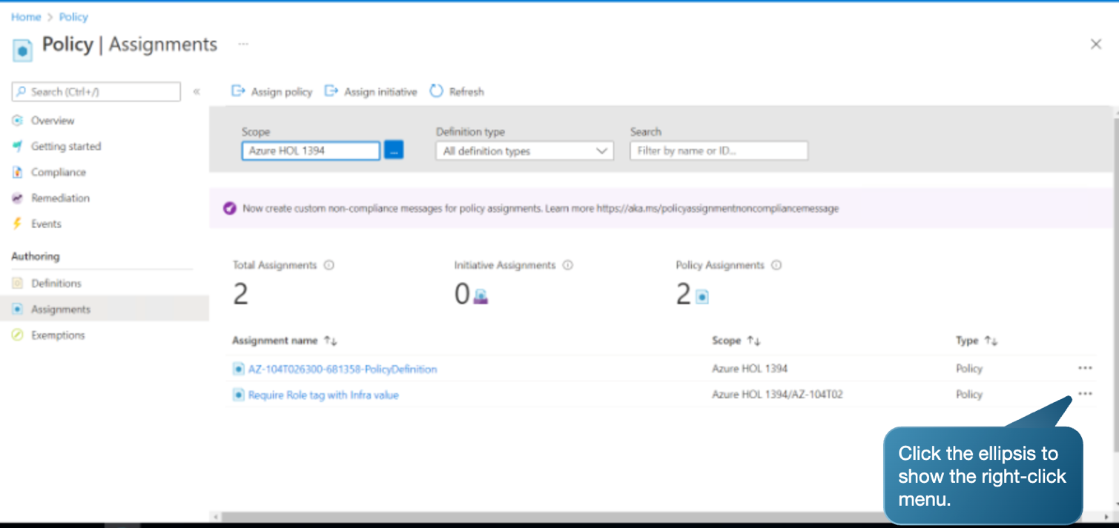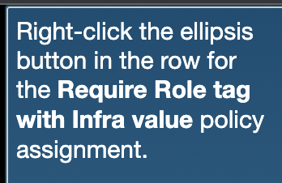

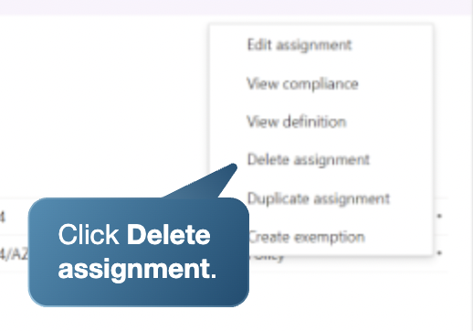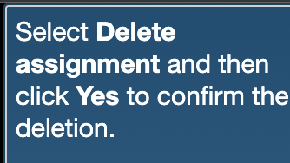

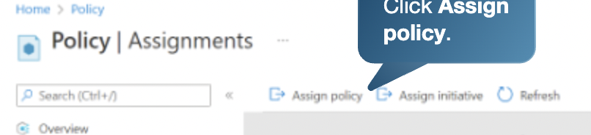

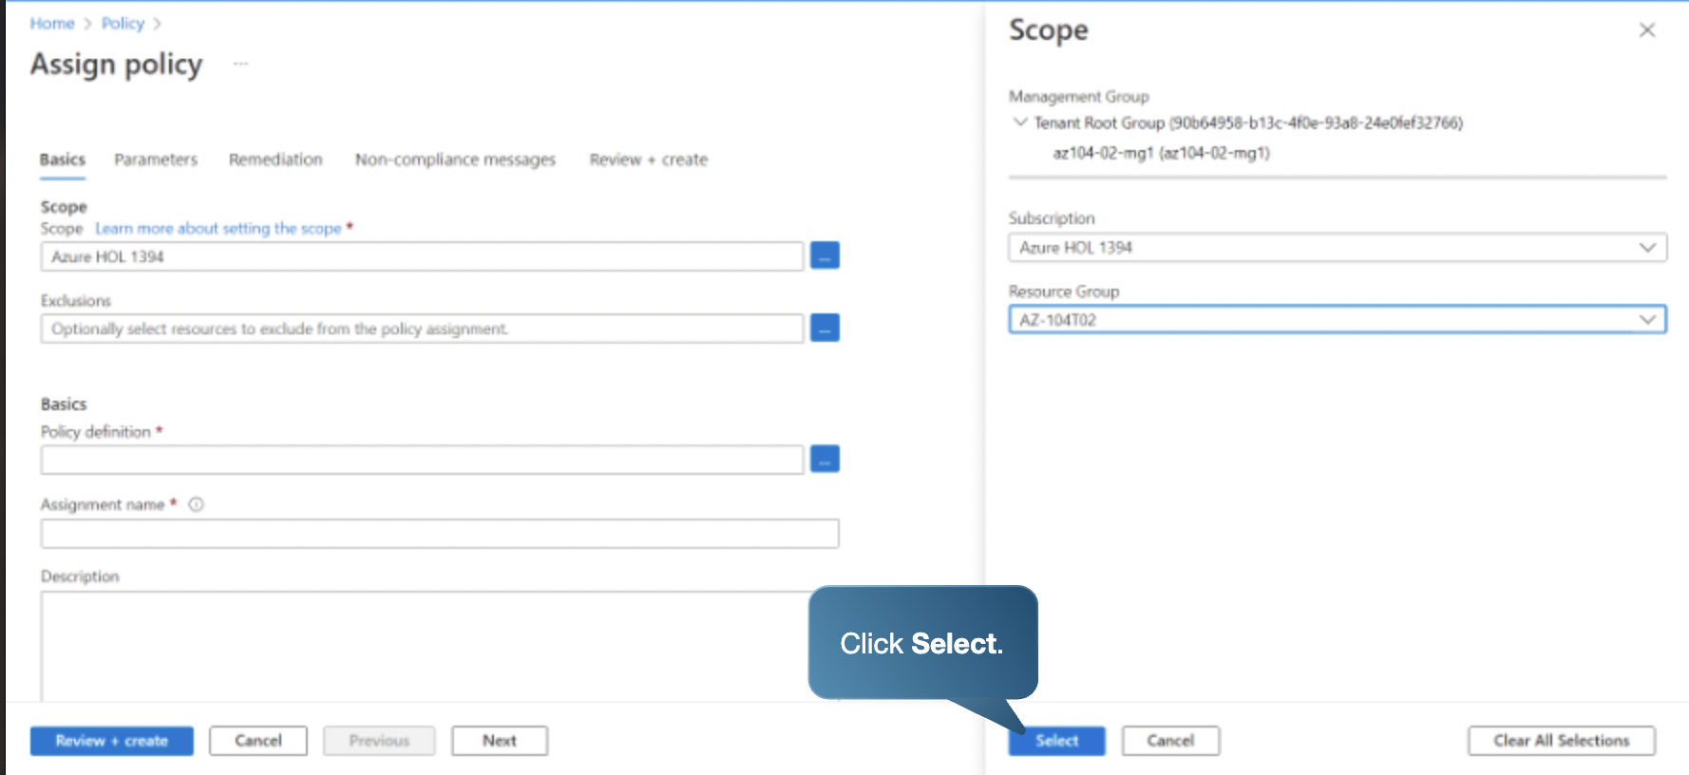



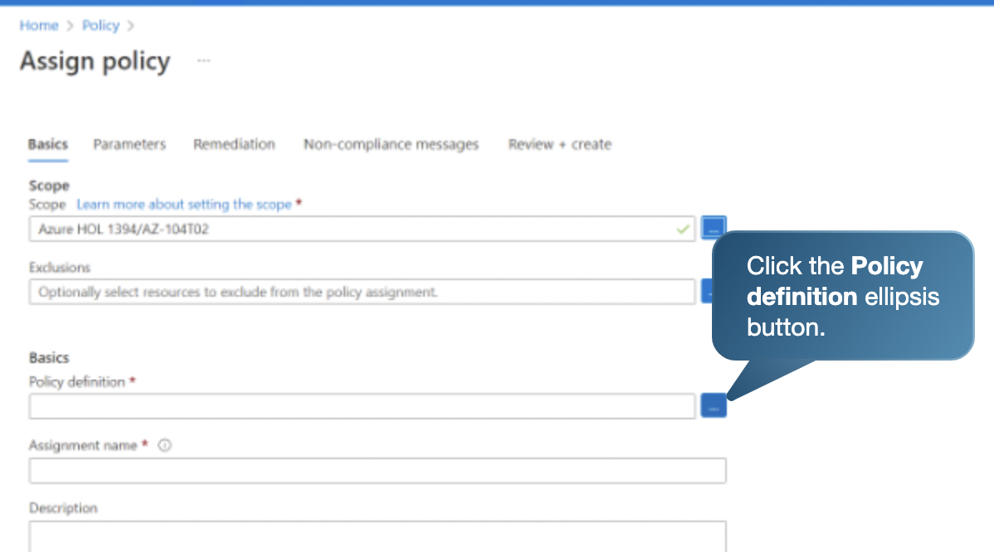

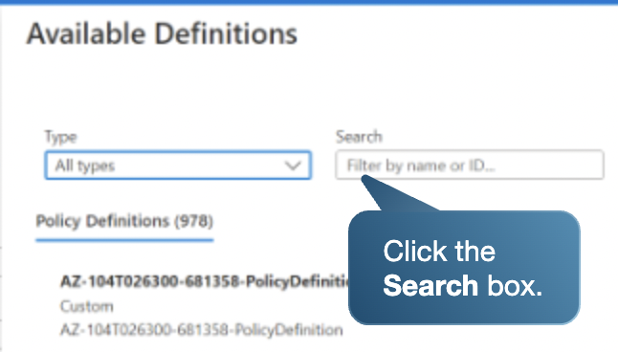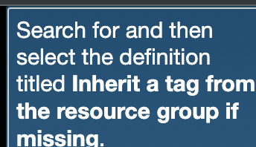

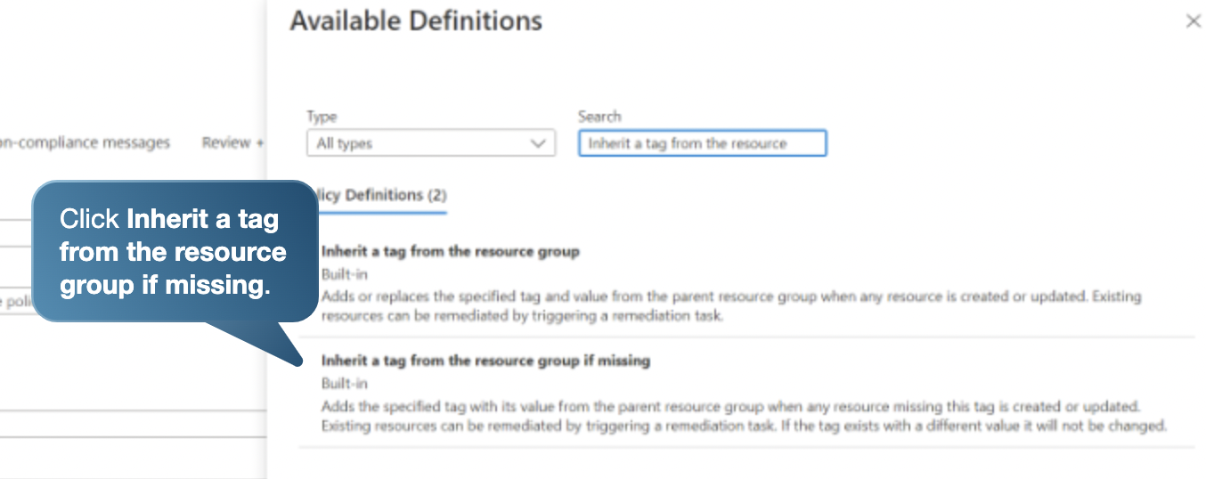

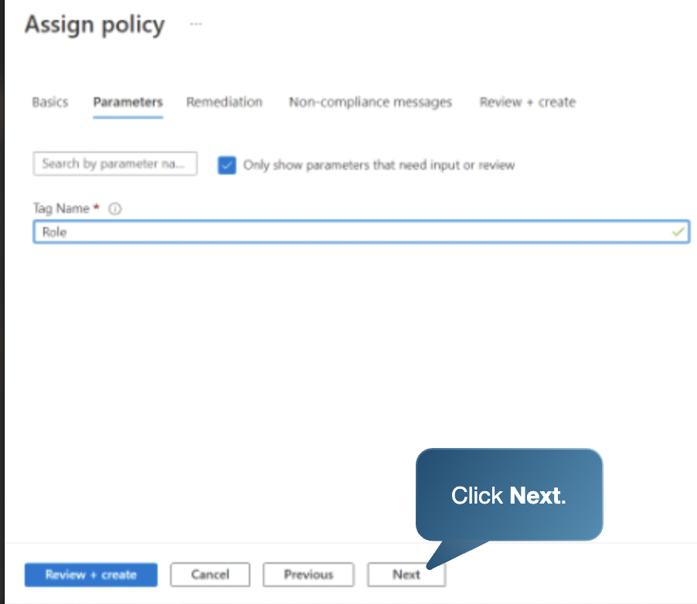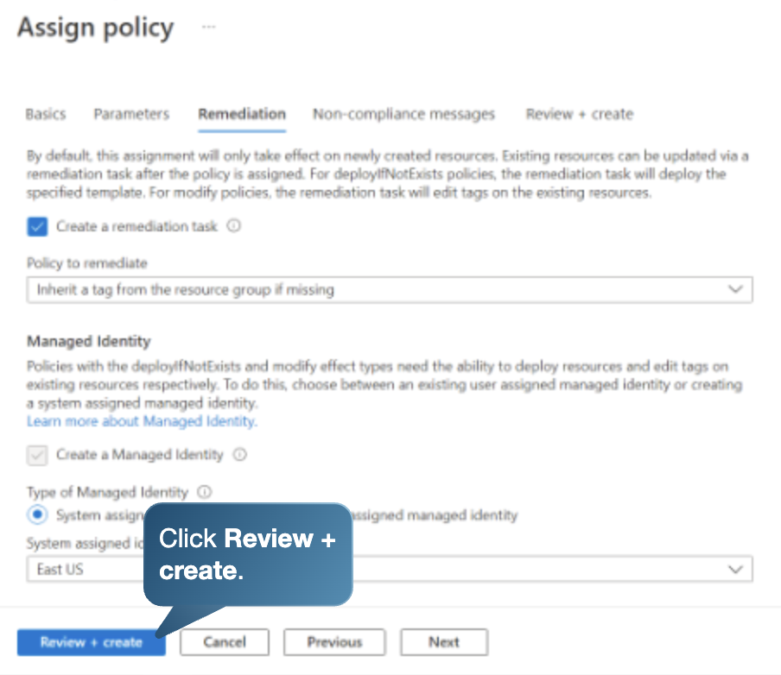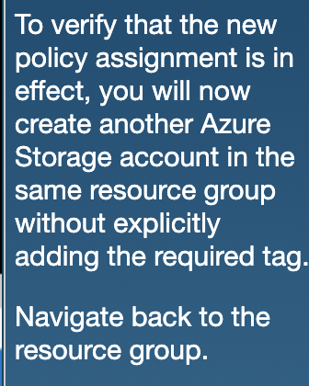

Yeni bir storage account oluşturduk aynı resource grubun altında

Bu sefer inherited etti tag.

